ROS基础 – 实训套件

实验案例 – 教学参考手册

7 语音交互

ROS基础 – 实训套件

实验案例 – 教学参考手册

6 06 Move_base与AMCL参数设置

ROS基础 – 实训套件

实验案例 – 教学参考手册

5 创建仿真机器人与现实机器人的同步

语音交互技术与应用

实验案例

7 语音指令控制

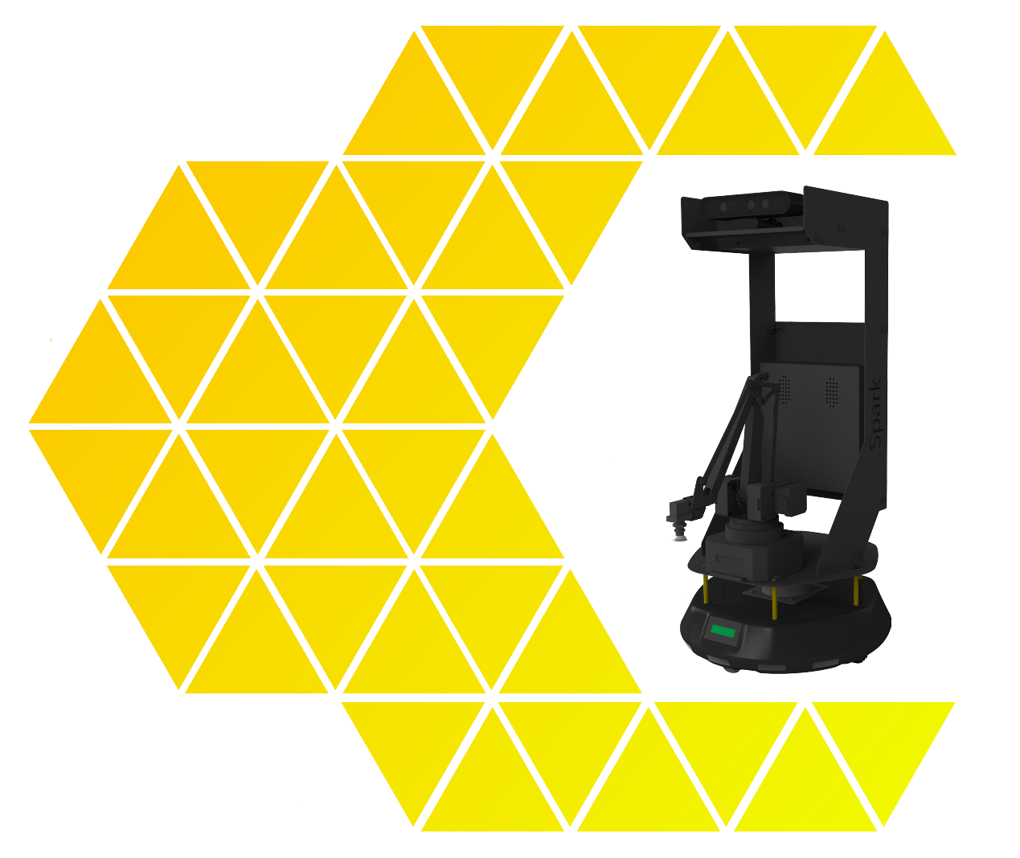

ROS基础 – 实训套件

实验案例 – 教学参考手册

7 语音交互

**目 录**

一、实验名称：语音指令控制 1

1、相关技能 1

2、相关知识点 1

3、实现效果 1

4、实验要求 2

5、实现思路 2

6、验证与测试 2

7、参考答案 2

# 一、实验名称：语音指令控制

## 1、相关技能

* 通过语音指令控制SPARK移动

## 2、相关知识点

* 语音识别
* 移动导航
* 参数调整

## 3、实现效果

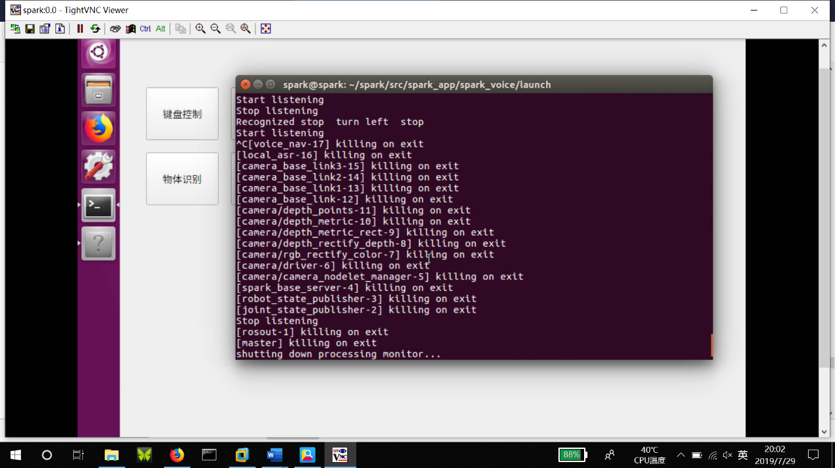

1 语音控制spark移动

## 4、实验要求

**本实验要求：安装语音识别功能，安装spark驱动，安装move_base，实现对spark的语音控制**

* 安装语音识别功能
* 安装Spark驱动
* 安装move_base

## 5、实现思路

5-1 安装pyaudio

sudo apt-get install python-pyaudio python3-pyaudio

5-2 安装Spark驱动

sudo cp $BASEPATH/doc/rules/3ilidar-usb-serial.rules /etc/udev/rules.d/

sudo cp $BASEPATH/doc/rules/uarm-usb-serial.rules /etc/udev/rules.d/

sudo cp $BASEPATH/doc/rules/spark-usb-serial.rules /etc/udev/rules.d/

sudo cp $BASEPATH/doc/rules/orbbec-usb.rules /etc/udev/rules.d/556-orbbec-usb.rules

sudo udevadm trigger

5-3 安装move_base

sudo apt-get install ros-kinetic-move-base

## 6、验证与测试

启动语音控制,当识别语音后，就能看到小车移动了

|  |
| --- |
| **+ 提示：**  $ roslaunch spark_voice voice_nav.launch |



## 7、参考答案

##voice_nav.launch

<launch>

<!--spark底盘驱动，机器人描述,底盘,相机-->

<include file="$(find

spark_bringup)/launch/driver_bringup.launch"/>

<!--spark键盘控制 “wsad”分别代表“前后左右”-->

<node pkg="spark_voice" type="local_asr.py" name="local_asr" />

<node pkg="spark_voice" type="voice_nav.py" name="voice_nav" />

</launch>

##local_asr.py

import rospy

from std_msgs.msg import String

import logging

import time

from threading import Thread, Event

from lib import Microphone

def main():

logging.basicConfig(level=logging.INFO)

quit_event = Event()

mic = Microphone(quit_event=quit_event)

pub = rospy.Publisher('voice/stt', String, queue_size=10)

rospy.init_node('local_asr', anonymous=True)

#rate = rospy.Rate(10) # 10hz

while not rospy.is_shutdown():

# if mic.wakeup('alexa'):

# print('Wake up\n')

data = mic.listen()

text = mic.recognize(data)

hello_str = "REC: %s" % text

rospy.loginfo(hello_str)

if text:

pub.publish(text)

#rate.sleep()

if __name__ == '__main__':

try:

main()

except rospy.ROSInterruptException:

pass

##voice_nav.py

#!/usr/bin/env python

# -*- coding: utf-8 -*-

import rospy

from geometry_msgs.msg import Twist

from std_msgs.msg import String

from math import copysign

class VoiceNav:

def __init__(self):

rospy.init_node('voice_nav')

rospy.on_shutdown(self.cleanup)

# Set a number of parameters affecting the robot's speed

self.max_speed = rospy.get_param("~max_speed", 0.4)

self.max_angular_speed = rospy.get_param("~max_angular_speed", 1.5)

self.speed = rospy.get_param("~start_speed", 0.1)

self.angular_speed = rospy.get_param("~start_angular_speed", 0.5)

self.linear_increment = rospy.get_param("~linear_increment", 0.05)

self.angular_increment = rospy.get_param("~angular_increment", 0.4)

# We don't have to run the script very fast

self.rate = rospy.get_param("~rate", 5)

r = rospy.Rate(self.rate)

self.STEPS = rospy.get_param("~steps", 20)

self.stp_counts=0

# A flag to determine whether or not voice control is paused

self.paused = False

# Initialize the Twist message we will publish.

self.cmd_vel = Twist()

# Publish the Twist message to the cmd_vel topic

self.cmd_vel_pub = rospy.Publisher('cmd_vel', Twist, queue_size=5)

# Subscribe to the /voice/stt topic to receive voice commands.

rospy.Subscriber('/voice/stt', String, self.speech_callback)

# A mapping from keywords or phrases to commands

self.keywords_to_command = {'stop': ['stop','停止'],

'forward': ['forward','前进'],

'backward': ['backward','后退'],

'turn left': ['turn left','左转'],

'turn right': ['turn right','右转']}

rospy.loginfo("Ready to receive voice commands")

# We have to keep publishing the cmd_vel message if we want the robot to keep moving.

while not rospy.is_shutdown():

self.stp_counts+=1

if(self.stp_counts>=self.STEPS):

self.cmd_vel = Twist()

self.stp_counts=0

self.cmd_vel_pub.publish(self.cmd_vel)

r.sleep()

def get_command(self, data):

# Attempt to match the recognized word or phrase to the

# keywords_to_command dictionary and return the appropriate

# command

for (command, keywords) in self.keywords_to_command.iteritems():

for word in keywords:

if data.find(word) > -1:

return command

def speech_callback(self, msg):

# Get the motion command from the recognized phrase

command = self.get_command(msg.data)

self.stp_counts=0

# Log the command to the screen

rospy.loginfo("Command: " + str(command))

# If the user has asked to pause/continue voice control,

# set the flag accordingly

if command == 'pause':

self.paused = True

elif command == 'continue':

self.paused = False

# If voice control is paused, simply return without

# performing any action

if self.paused:

return

# The list of if-then statements should be fairly

# self-explanatory

if command == 'forward':

self.cmd_vel.linear.x = self.speed

self.cmd_vel.angular.z = 0

elif command == 'rotate left':

self.cmd_vel.linear.x = 0

self.cmd_vel.angular.z = self.angular_speed

elif command == 'rotate right':

self.cmd_vel.linear.x = 0

self.cmd_vel.angular.z = -self.angular_speed

elif command == 'turn left':

if self.cmd_vel.linear.x != 0:

self.cmd_vel.angular.z += self.angular_increment

else:

self.cmd_vel.angular.z = self.angular_speed

elif command == 'turn right':

if self.cmd_vel.linear.x != 0:

self.cmd_vel.angular.z -= self.angular_increment

else:

self.cmd_vel.angular.z = -self.angular_speed

elif command == 'backward':

self.cmd_vel.linear.x = -self.speed

self.cmd_vel.angular.z = 0

elif command == 'stop':

# Stop the robot! Publish a Twist message consisting of all zeros.

self.cmd_vel = Twist()

elif command == 'faster':

self.speed += self.linear_increment

self.angular_speed += self.angular_increment

if self.cmd_vel.linear.x != 0:

self.cmd_vel.linear.x += copysign(self.linear_increment, self.cmd_vel.linear.x)

if self.cmd_vel.angular.z != 0:

self.cmd_vel.angular.z += copysign(self.angular_increment, self.cmd_vel.angular.z)

elif command == 'slower':

self.speed -= self.linear_increment

self.angular_speed -= self.angular_increment

if self.cmd_vel.linear.x != 0:

self.cmd_vel.linear.x -= copysign(self.linear_increment, self.cmd_vel.linear.x)

if self.cmd_vel.angular.z != 0:

self.cmd_vel.angular.z -= copysign(self.angular_increment, self.cmd_vel.angular.z)

elif command in ['quarter', 'half', 'full']:

if command == 'quarter':

self.speed = copysign(self.max_speed / 4, self.speed)

elif command == 'half':

self.speed = copysign(self.max_speed / 2, self.speed)

elif command == 'full':

self.speed = copysign(self.max_speed, self.speed)

if self.cmd_vel.linear.x != 0:

self.cmd_vel.linear.x = copysign(self.speed, self.cmd_vel.linear.x)

if self.cmd_vel.angular.z != 0:

self.cmd_vel.angular.z = copysign(self.angular_speed, self.cmd_vel.angular.z)

else:

return

self.cmd_vel.linear.x = min(self.max_speed, max(-self.max_speed, self.cmd_vel.linear.x))

self.cmd_vel.angular.z = min(self.max_angular_speed, max(-self.max_angular_speed, self.cmd_vel.angular.z))

def cleanup(self):

# When shutting down be sure to stop the robot!

twist = Twist()

self.cmd_vel_pub.publish(twist)

rospy.sleep(1)

if __name__=="__main__":

try:

VoiceNav()

rospy.spin()

except rospy.ROSInterruptException:

rospy.loginfo("Voice navigation terminated.")